- What is a system in software engineering?***
-
A system is a group of connected parts (software, hardware, people, data) that work together to do a task.
Software – programs or apps
Hardware – computers, servers, devices
Users – people who use the system
Data – input, output, and stored information
Example: A railway booking system where software, users, and servers work together.

- What are the key characteristics of a system?***
-
Purposeful – Made to achieve a goal
>> Like a ticket booking system is built to sell tickets
Structured – Has a planned design and process
>> Each step is arranged clearly like in online shopping
Interconnected – All parts depend on each other
>> If payment fails, order can't be placed
Boundary-defined – Has fixed inputs and outputs
>> Input: login, Output: access to dashboard
Operates in an environment – Works with people or other systems
>> Like weather apps use data from external sources

- What are the stages of the System Development Life Cycle (SDLC)?***
-
Planning – Decide what to build
>> Like deciding to build a school result system
System Analysis – Study the current system and user needs
>> Check how marks are currently calculated
System Design – Make a blueprint of the system
>> Design forms, flow, and screens
Development – Build the system
>> Develop using code and tools
Testing – Find and fix problems
>> Check if marks show correctly
Deployment – Launch the system for users
>> Make it live for school staff and students
Maintenance – Fix and update over time
>> Add new subjects later if needed
- What is the role of a System Analyst?***
- A system analyst connects business needs with technical solutions by planning and helping in system development.
Example: Like asking teachers what features they need in a school system and explaining that to developers.
- What are the main responsibilities of a System Analyst?***
-
Requirement Gathering – Understand what users want
>> Talk to teachers to find out what reports they need
Feasibility Study – Check if it can be done
>> Check budget, time, and skills
System Design – Help plan how the system will work
>> Suggest how marks and grades will be calculated
Communication – Talk with users and developers
>> Be the bridge between school and software team
Problem Solving – Fix existing system issues
>> Help make the report printing faster
Documentation – Write clear system details
>> Create system manuals or requirement docs
Testing & Evaluation – Make sure it works well
>> Test if login and dashboard show correctly
- Difference between software & system development life cycle
-
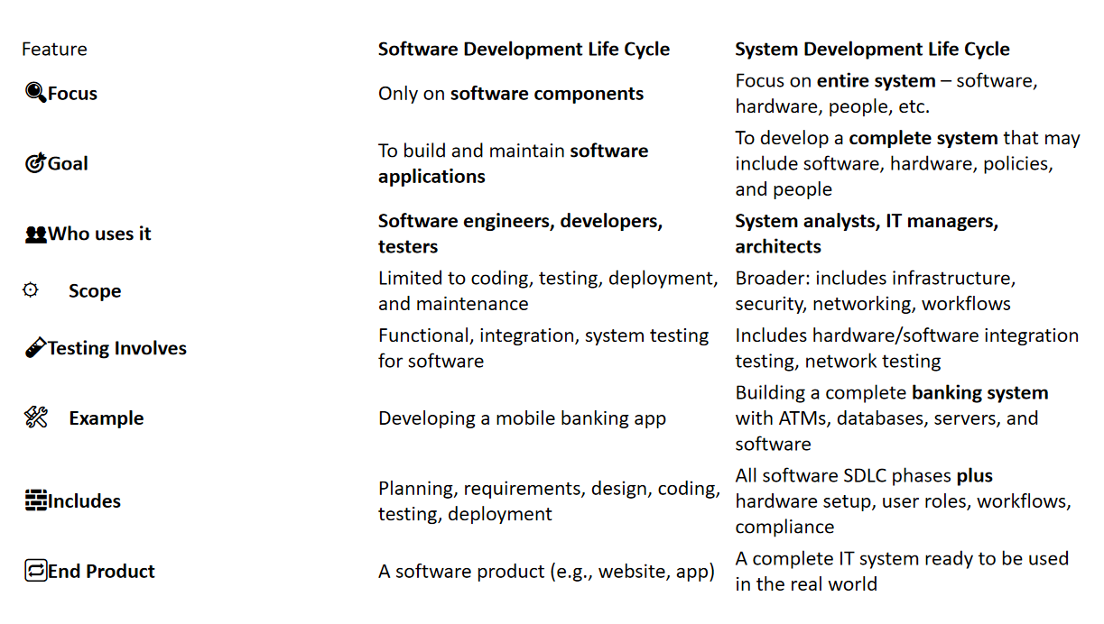

- Briefly discuss about MIS (Management Information System),purpose of MIS & components of MIS.***
-
MIS is a system that gives managers the data they need to make good decisions.
>>Example: A sales MIS shows weekly earnings to help plan promotions.
Purpose of MIS:
To collect, manage, and share useful information for planning and decisions.
>> Like showing which products sell best in a shop.
Components of MIS:
Hardware – Devices like computers and printers
>>Like the manager’s laptop
Software – Programs used to process data
>>Like Excel or a sales tracking app
Database – Where data is stored
>>Customer records, sales logs, etc.
People – Users of the system
>>Managers, analysts, staff
Procedures – Rules for using the system
>>Like how often data is updated
- What is structured analysis?& What are the tools of structured analysis?***
-
Structured analysis is a method to break down a system clearly using diagrams before building it.
>>Like using a map before starting construction.
Tool Structure:
DFD (Data Flow Diagram) – Shows how data moves
>>Shows login data going to database
ERD (Entity-Relationship Diagram) – Shows data and links
>>Shows student linked to class and result
Data Dictionary – Explains what each data means
>>“Student ID” means a unique roll number
Process Specification (P-Specs) – Explains each process
>>Describes how marks are calculated
Decision Trees/Tables – Show conditions and actions
>>If attendance < 75%, show warning

- 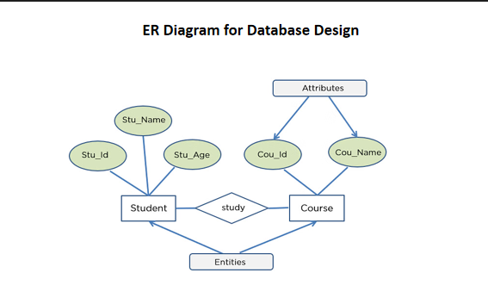

- 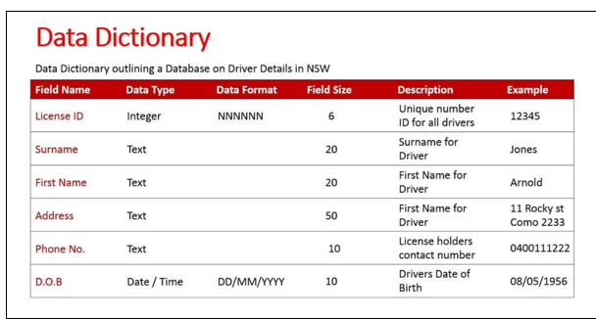

- 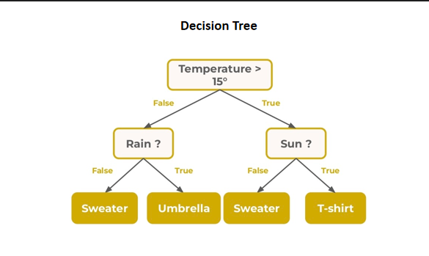

- What is Cost/Benefit Analysis (CBA) in system engineering?What is included in Cost/Benefit Analysis?What is the purpose of Cost/Benefit Analysis?
-
CBA compares project costs vs. benefits to see if it's worth doing.
>>If a new system costs 50k but saves 80k, it’s a good deal.
It includes:
Costs – Hardware, software, salaries, training
>>Buying computers or paying developers
Benefits – Saves time, reduces errors, better planning
>>Faster result processing saves hours of work
Purpose:
To check if the system gives more value than it costs.
>>Only approve the project if benefit > cost.
- What are the stages of system design?***
-
Preliminary Design – Plan the main structure
>> Layout of modules like login, result, fees
Detailed Design – Design the internal parts
>>What each page or report will show
Interface Design – Plan user interaction
>>Where buttons and inputs will be placed
Database Design – Plan how data will be stored
>>Tables for students, teachers, subjects
System Architecture – Decide tech setup
>>Choose servers, network, and security
Review – Check if design meets goals
>>Recheck if everything needed is included

